Deel 6 Huiswerk

Opgave 1: Kies een stelling, filosofeer erover en schrijf je gedachten uit.
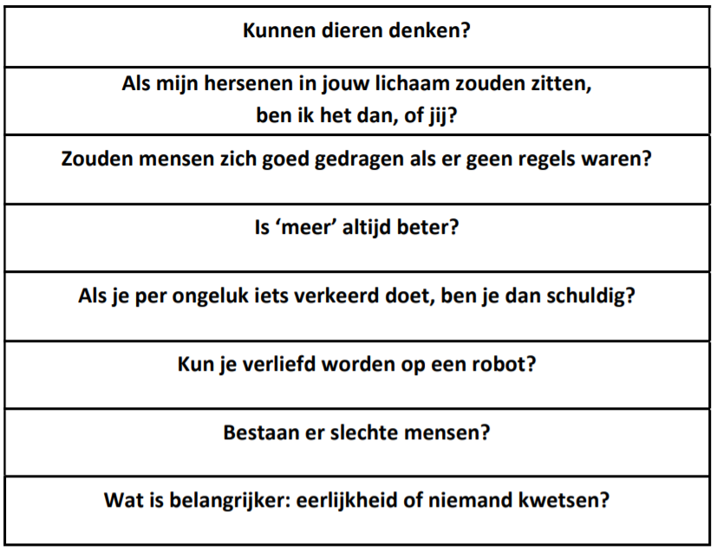

___________________________________________________________________________
___________________________________________________________________________
___________________________________________________________________________
___________________________________________________________________________
___________________________________________________________________________
___________________________________________________________________________
___________________________________________________________________________
___________________________________________________________________________
___________________________________________________________________________
___________________________________________________________________________
___________________________________________________________________________
___________________________________________________________________________
___________________________________________________________________________
___________________________________________________________________________
___________________________________________________________________________
___________________________________________________________________________

Opgave 2: Verbind de Griekse letters in de juiste alfabetische volgorde. Welke tekening zie je verschijnen?

